DBT Assignment 2
- Write a query that produces all rows from the Customers table for which the salesperson’s number is 1001.
- SELECT * FROM customers WHERE snum = 1001;
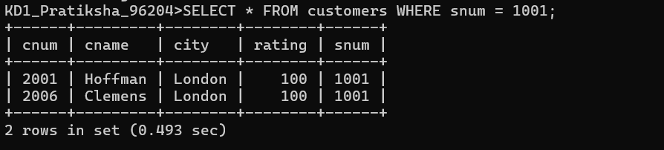
- Write a select command that produces the rating followed by the name of each customer in San Jose.
- SELECT cname, rating FROM customers WHERE city = 'San Jose';
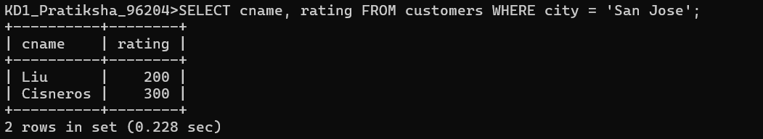
- Write a query that will produce the snum values of all salespeople from the Orders table (with the duplicate values suppressed).
- SELECT DISTINCT snum FROM orders;
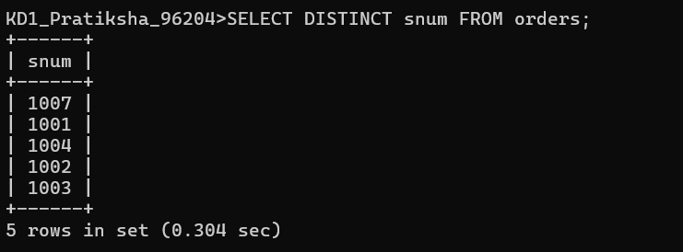
- Write a query that will display all the orders for amount more than Rs. 1,000.
- SELECT * FROM orders WHERE amt > 1000;
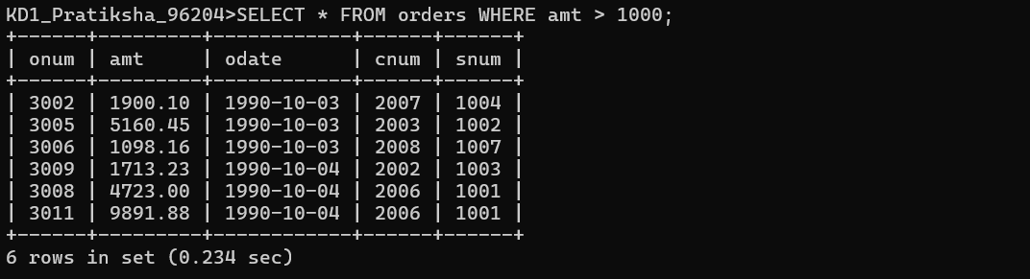
- Write a query that will give you the names and cities of all salespeople in London with a commission above 0.10.
- SELECT sname, city FROM salespeople WHERE city = 'London' AND comm > 0.10;
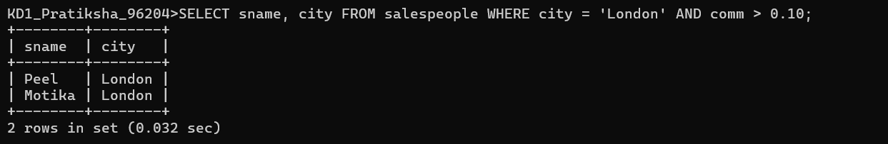
- Write an SQL query that returns all customers who have a rating greater than 100, along with the customers located in Rome regardless of their rating.
- SELECT cname, cnum FROM customers WHERE rating > 100 OR city = 'Rome';
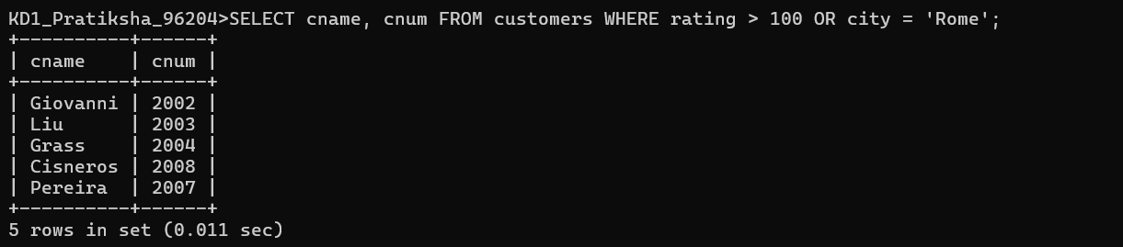
- What will be the output from the following query? Select * from Orders where (amt < 1000 OR NOT (odate = ‘1990-10- 03’ AND cnum > 2003));
- SELECT * FROM orders WHERE (amt < 1000 OR NOT(odate = '1990-10-03' AND cnum > 2003));
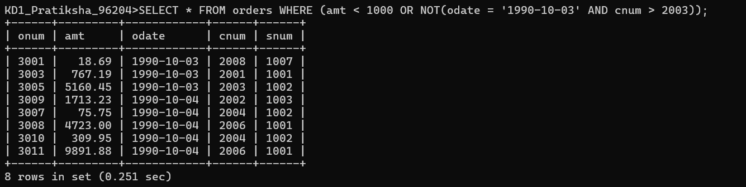
- What will be the output of the following query? Select * from Orders where NOT (odate = ‘1990-10-03’ OR snum >1006) AND amt >= 1500;
- SELECT * FROM orders WHERE NOT (odate = '1990-10-03' OR snum > 1006) AND amt >= 1500;
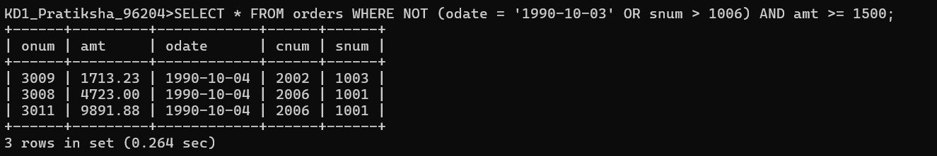
- What is a simpler way to write this query? Select snum, sname, city, comm from Salespeople Where (comm >= .12 AND comm <= .14);
- SELECT snum, sname, city comm FROM salespeople WHERE comm BETWEEN .12 AND .14;
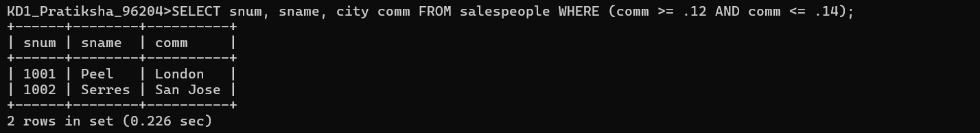
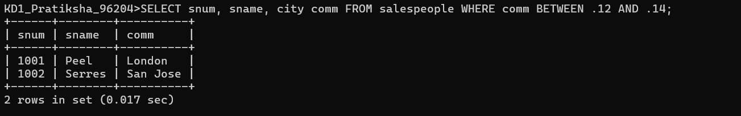
- Write a query that selects all orders except those with amount less than 100.
- SELECT * FROM orders WHERE amt >= 100;
